


OPTIMIZING USER, GROUP, AND ROLE MANAGEMENT WITH ACCESS CONTROL AND WORKFLOWS

Team Id: NM2025TMID08517
Team Members: 4

Team Leader : VAISHNAVI R
Team Member 1 : VASANTHAN G
Team Member 2 : VENKATESH
Team Member 3 : VENKATESWARAN B

Problem Context:
In a small project environment, a Project Manager (Alice) and a Team Member (Bob) are responsible for delivering tasks. However, the absence of well-defined roles, access restrictions, and structured workflows often creates confusion in responsibilities, accountability, and progress monitoring.

Objectives:
- Role Definition: Clearly outline the duties of Alice as Project Manager and Bob as Team Member, ensuring both responsibility and access boundaries are transparent.
- Access Control: Introduce mechanisms that limit Bob’s ability to create or edit projects beyond his assigned tasks, while still allowing him to view and update his responsibilities.
- Workflow Organization: Establish a structured process that enables Alice to assign work, track task progress, and oversee completion in a timely and efficient manner.

Key Skills/Tools: Users, Groups, Roles, Tables, Access Control Lists (ACL), Workflow/Flow Designer.

TASK INITIATION
Milestone 1: Users
Activity 1: Create Users

- Open service now

- Click on All >> search for users

- Select Users under system security

- Click on new

- Fill the following details to create a new user

- Click on submit
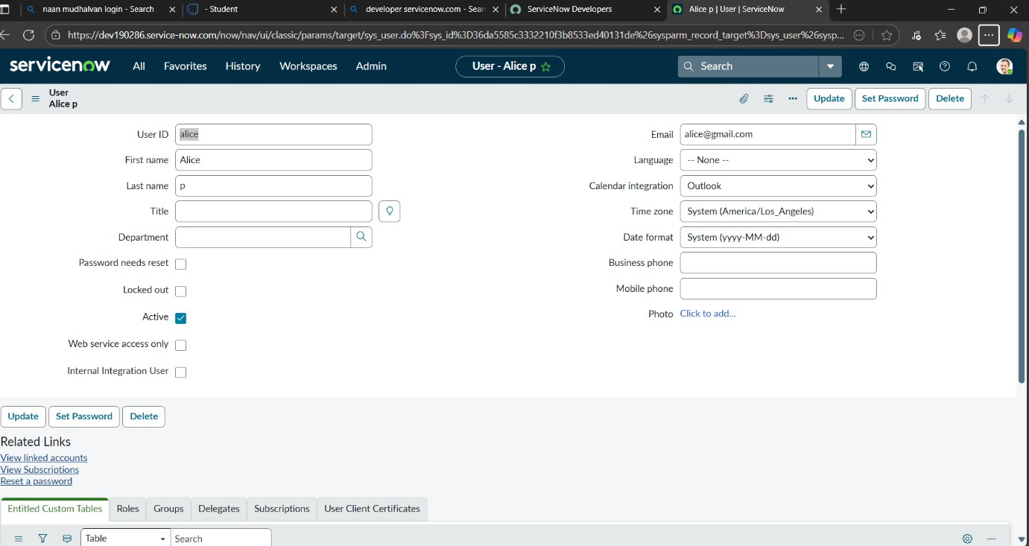

Create one more user:

- Create another user with the following details

- Click on submit
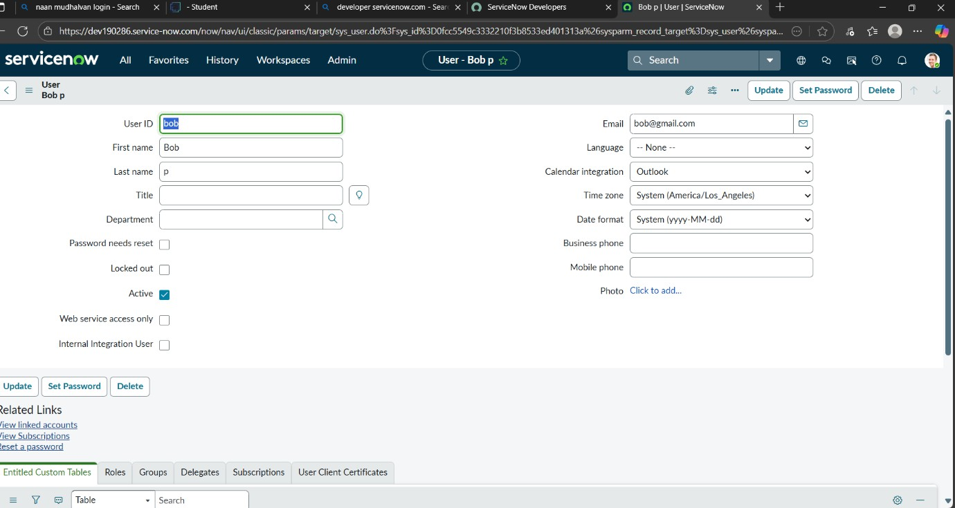

Milestone 2: Groups Activity 1: Create Groups
- Open service now.

- Click on All >> search for groups

- Select groups under system security

- Click on new

- Fill the following details to create a new group

- Click on submit.

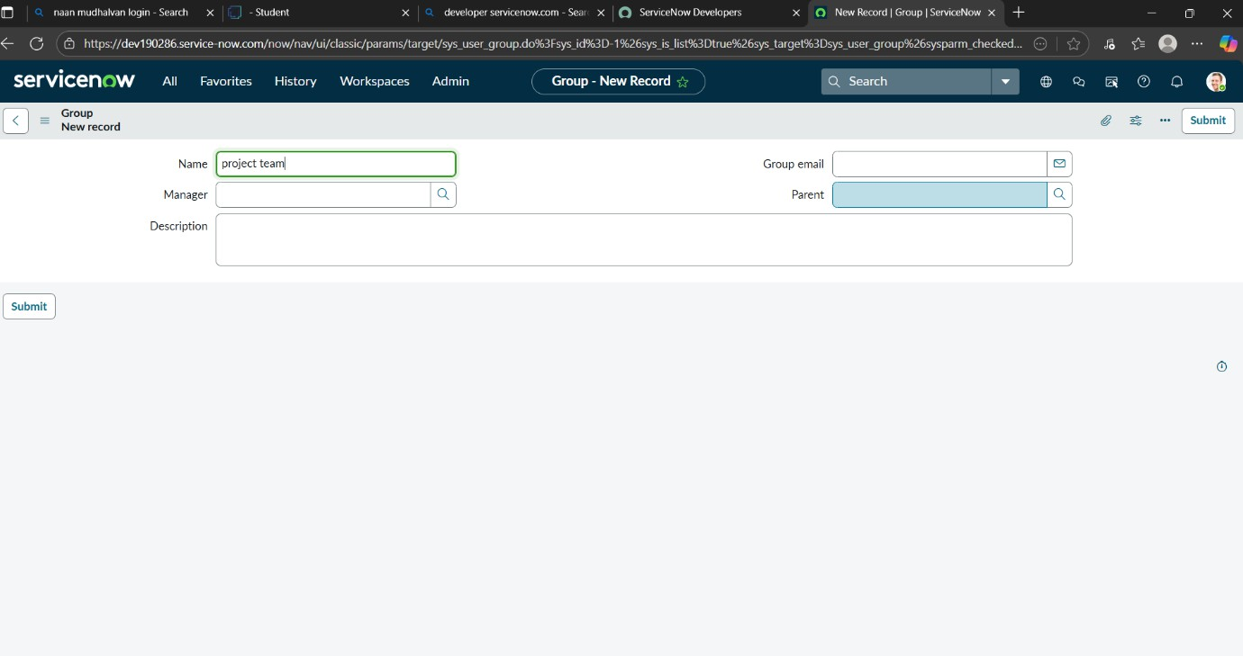
Milestone 3: Roles Activity 1: Create roles
- Open service now.

- Click on All >> search for roles

- Select roles under system security

- Click on new

- Fill the following details to create a new role

- Click on submit.
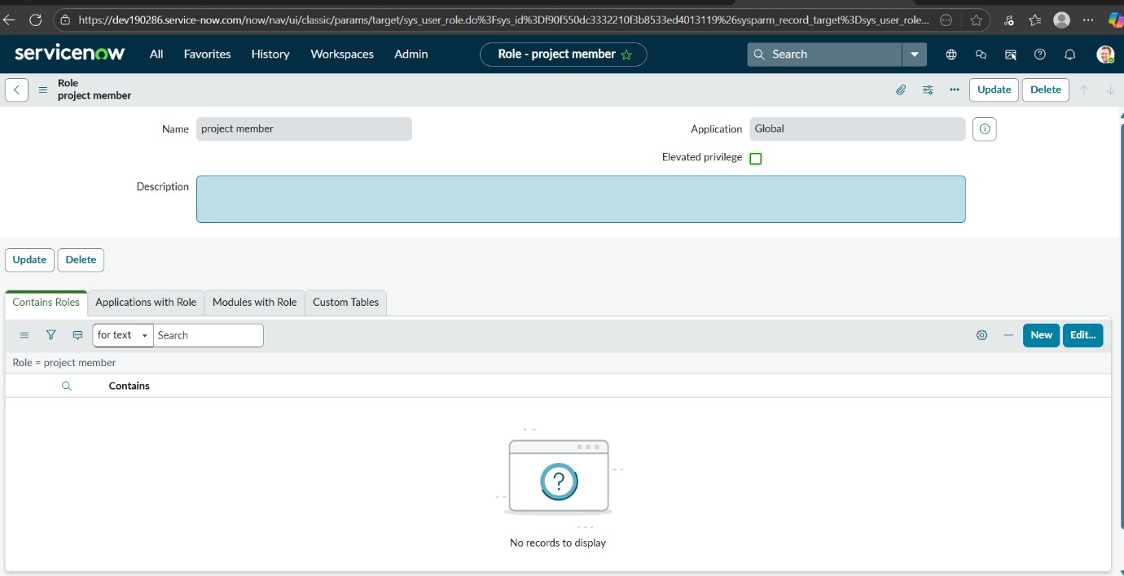

Create one more role:

- Create another role with the following details

- Click on submit
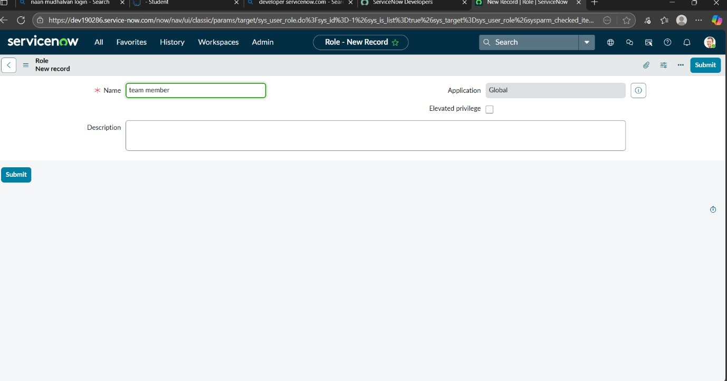

Milestone 4: Table Activity 1: Create Table
- Open service now.

- Click on All >> search for tables

- Select tables under system definition

- Click on new

- Fill the following details to create a new table Label: project table
Check the boxes Create module & Create mobile module

- Under new menu name: project table

- Under table columns give the columns

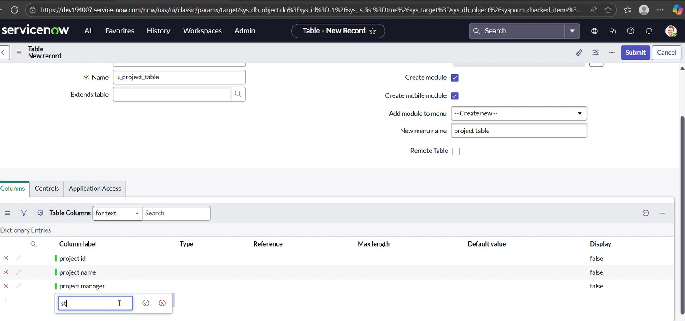

- Click on submit
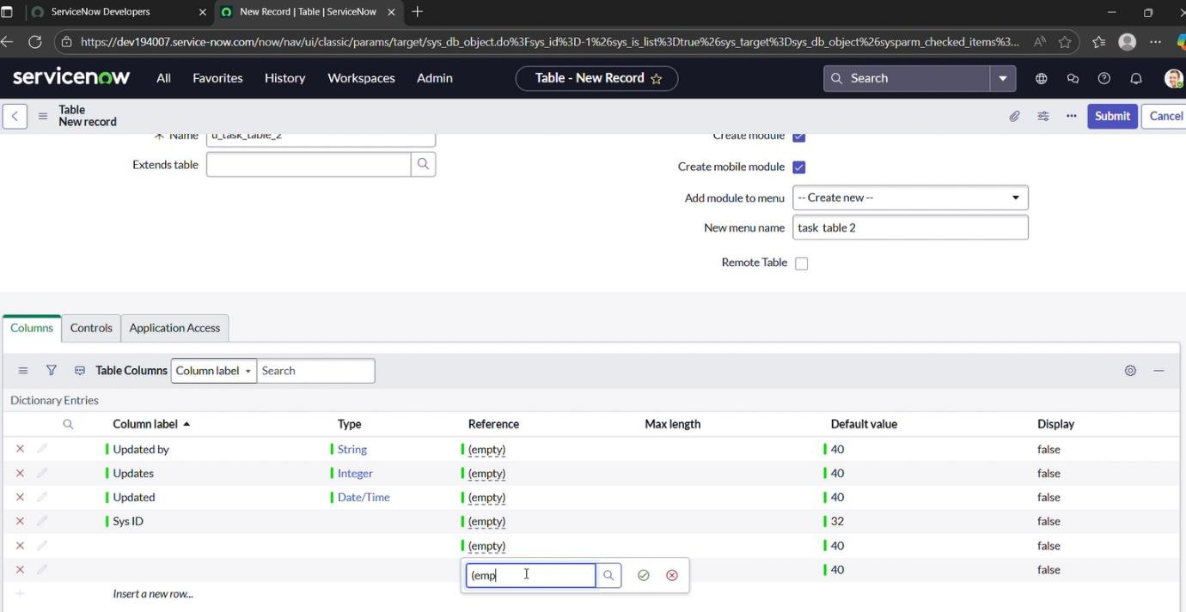

Create one more table:

- Create another table as: task table 2 and fill with following details.

- Click on submit.
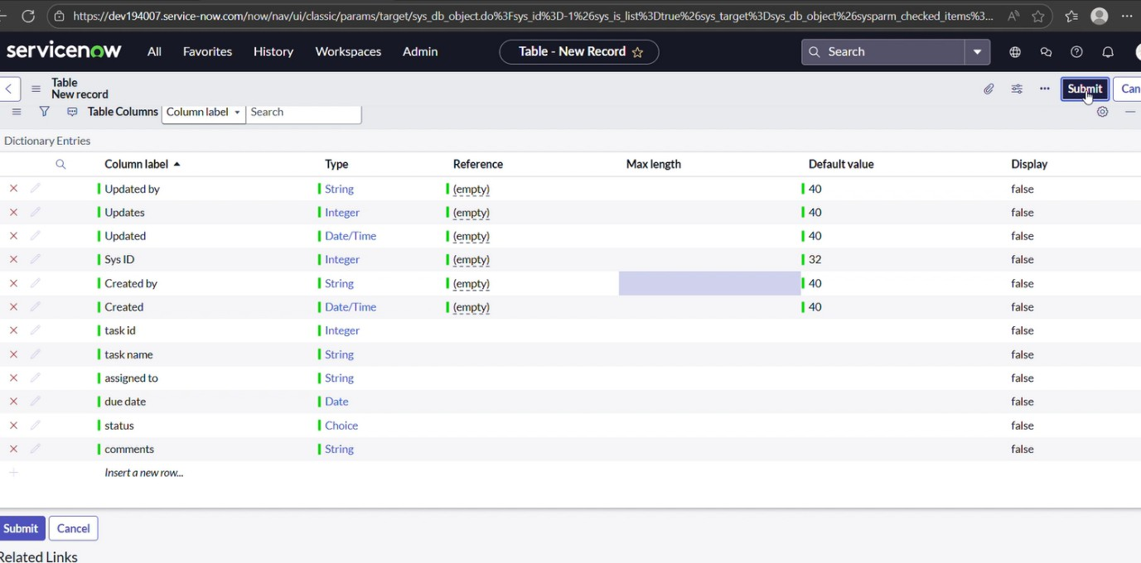
Milestone 5: Assign users to groups
Activity 1: Assign users to project team group
- Open service now.

- Click on All >> search for groups

- Select tables under system definition

- Select the project team group

- Under group members

- Click on edit

- Select alice p and bob p and save

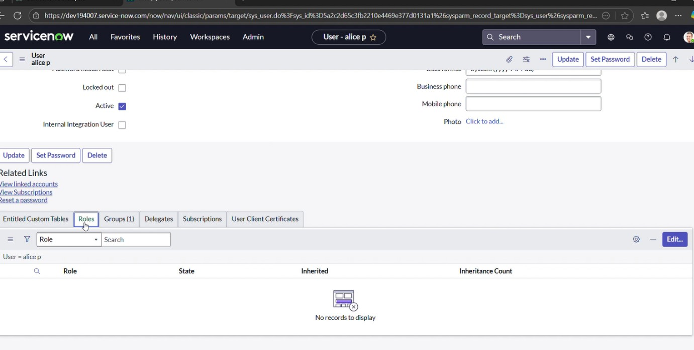

Milestone 6: Assign roles to users Activity 1: Assign roles to alice user
- Open servicenow.Click on All >> search for user

- Select tables under system definition

- Select the project manager user

- Under project manager

- Click on edit

- Select project member and save

- click on edit add u_project_table role and u_task_table role

- click on save and update the form.

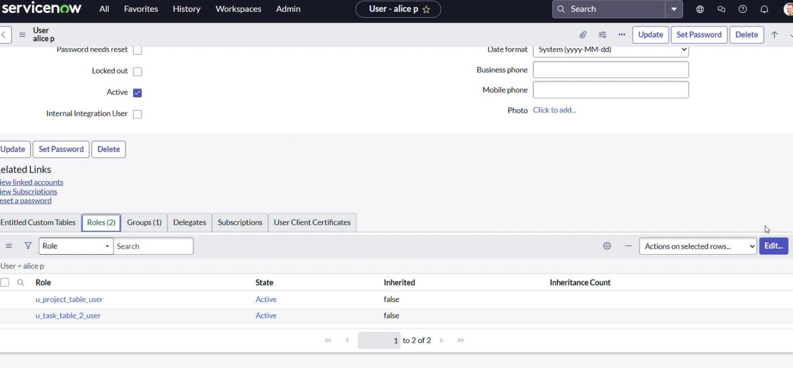

Activity 2: Assign roles to bob user
- Open servicenow.Click on All >> search for user

- Select tables under system definition

- Select the bob p user

- Under team member

- Click on edit

- Select team member and give table role and save

- Click on profile icon Impersonate user to bob

- We can see the task table2.

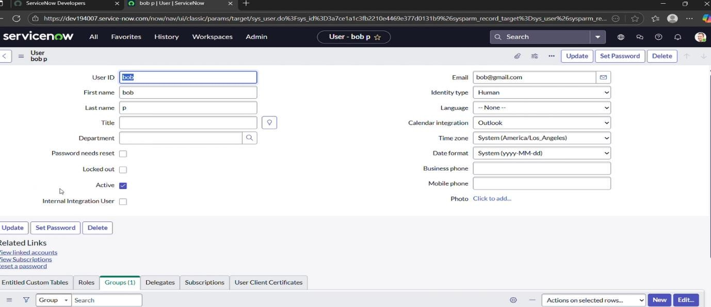
Milestone 7: Application access
Activity 1: Assign table access to application
- while creating a table it automatically create application and module for that table

- Go to application navigator search for search project table application

- Click on edit module

- Give project member roles to that application

- Search for task table2 and click on edit application.

- Give the project member and team member role for task table 2 application
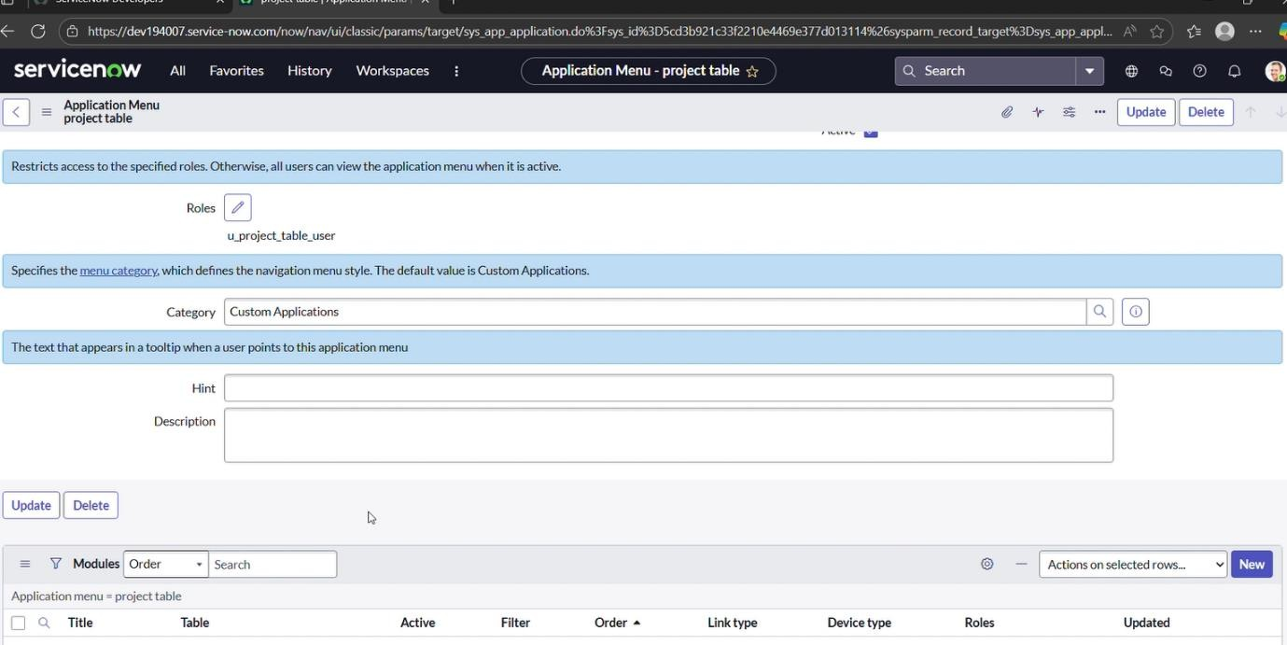

Milestone 8: Access control list Activity 1: Create ACL
- Open service now.

- Click on All >> search for ACL

- Select Access Control (ACL) under system security

- Click on elevate role

- Click on new
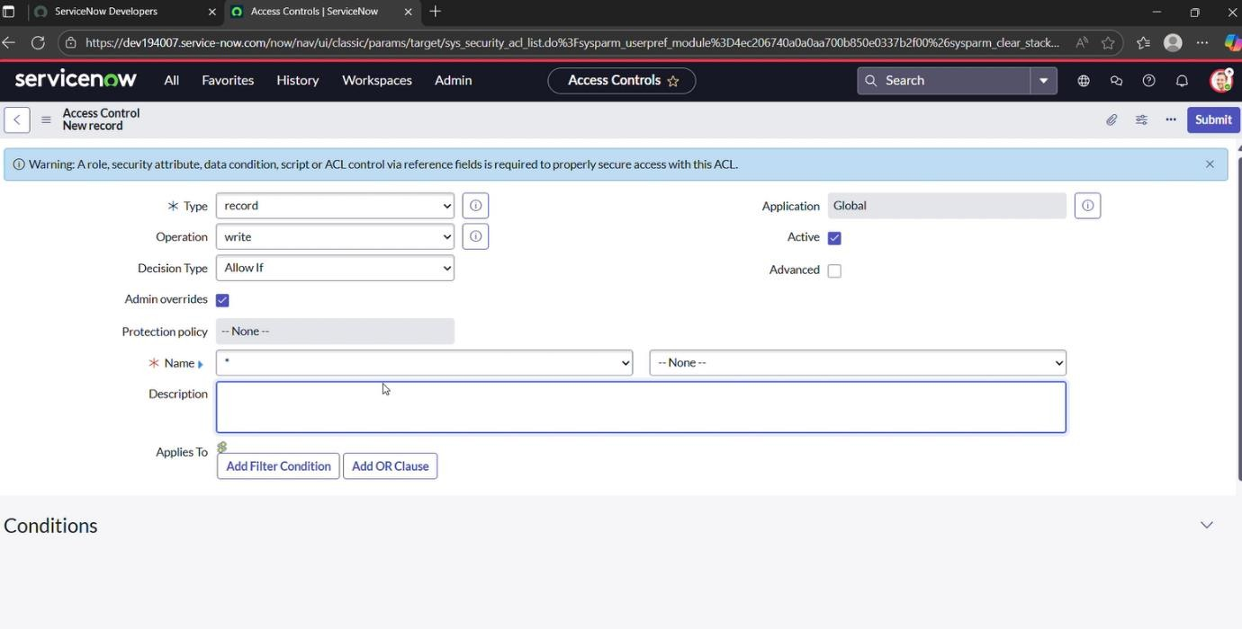
- Fill the following details to create a new ACL

- Scroll down under requires role

- Double click on insert a new row

- Give task table and team member role

- Click on submit

- Similarly create 4 acl for the following fields

- Click on profile on top right side

- Click on impersonate user

- Select bob user

- Go to all and select task table2 in the application menu bar

- Comment and status fields have the edit access

Milestone 9: Flow
Activity 1: Create a Flow to Assign operations ticket to group
- Open service now.

- Click on All >> search for Flow Designer

- Click on Flow Designer under Process Automation.

- After opening Flow Designer Click on new and select Flow.

- Under Flow properties Give Flow Name as “task table”.

- Application should be Global.

- Click build flow.
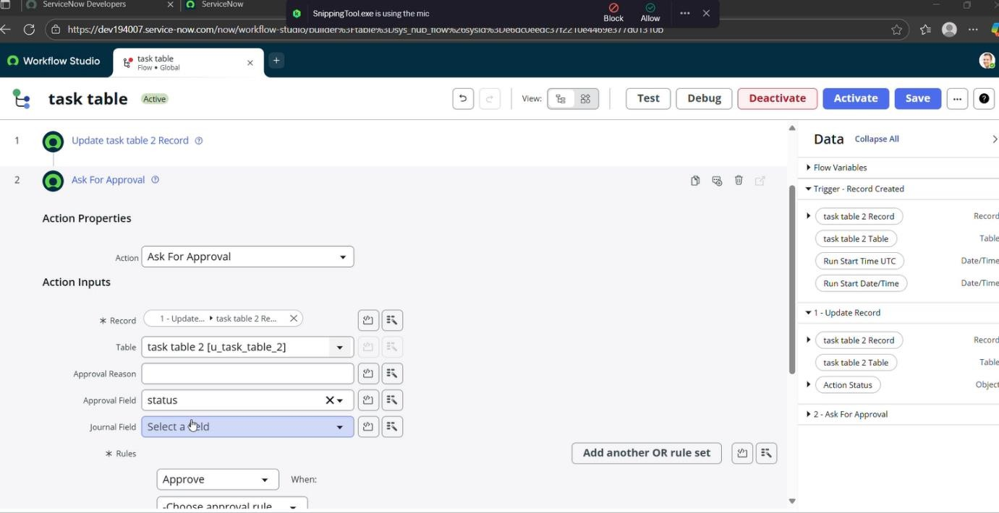

next step:

- Click on Add a trigger

- Select the trigger in that Search for “create record” and select that.

- Give the table name as “task table”.

- Give the Condition as Field: status Operator: is Value: in progress

Field: comments Operator: is Value: feedback Field: assigned to Operator: is Value: bob
- After that click on Done.

Next step:

- Click on Add an action.

- Select action in that, search for “update records”.

- In Record field drag the fields from the data navigation from Right Side (Data pill)

- Table will be auto assigned after that

- Add fields as “status” and value as “completed”

- Click on Done.
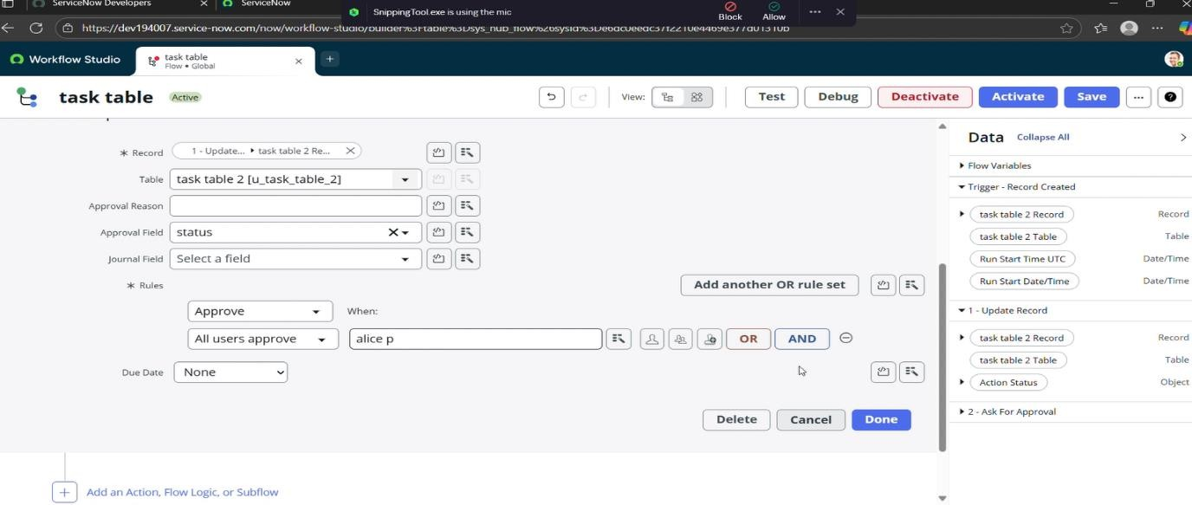

Next step:

- Now under Actions.

- Click on Add an action.

- Select action in that, search for “ask for approval”.

- In Record field drag the fields from the data navigation from Right side

- Table will be auto assigned after that

- Give the approve field as “status”

- Give approver as alice p

- Click on Done.

- Go to application navigator search for task table.

- It status field is updated to completed

- Go to application navigator and search for my approval

- Click on my approval under the service desk.

- Alice p got approval request then right click on requested then select approved
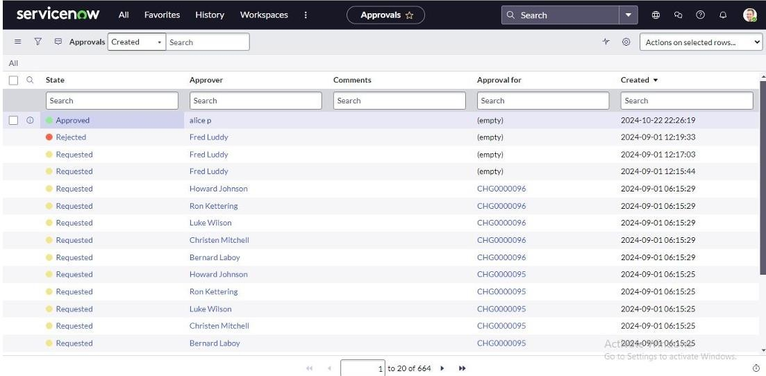

Conclusion:
This approach provides a streamlined system for managing projects by defining roles, applying access restrictions, and organizing workflows. It helps the team collaborate effectively, improves accountability, simplifies task tracking, and ensures successful project delivery.

